**CNM Grant Procurement Memo**

Applies to:

Funding source (choose one):

State Federal

* Federal purchases $10,000 and above or,
* State purchases $20,000 and above
* Purchases less than $60,000

**Grant/Project Title:** Dept of Education-Quantum Learning Lab

**Project Director/PI:** Brian Rashap

**Grant number within Workday:** GR300429

**Description of goods or services:** Short description of what is needed

Optical post and mounting parts

**Benefit to grant and CNM:** Describe how/why this purchase will meet objectives of project.

Optical posts and mounting parts to install Quantum chamber in Quantum Learning Lab

**Estimated dollar amount:** $8,447.60

**Rationale for method of procurement:** Describe how quotes were gathered

Direct Quotes from Vendors or Vendor Websites

**Contractor selection or rejection:**  Name each vendor and indicate whether selected or rejected. This will document and justify the decision for procurement.

* VENDOR #1: ThorLabs
  + ThorLabs: ACCEPTED
  + Amount of Quote: $8447.60
  + Justification: Lowest Quote.
* VENDOR #2: MKS/Newport
  + QuTools: REJECTED
  + Amount of Quote: $10,796.46
  + Justification: More expensive
* VENDOR #3: Edmunds
  + Newport / MKS: REJECTED
  + Amount of Quote: $9,990 + shipping
  + Justification: More expensive, doesn’t include optical breadboard

**VENDOR #1: ThorLabs**

**VENDOR # 2 – MKS/Newport**

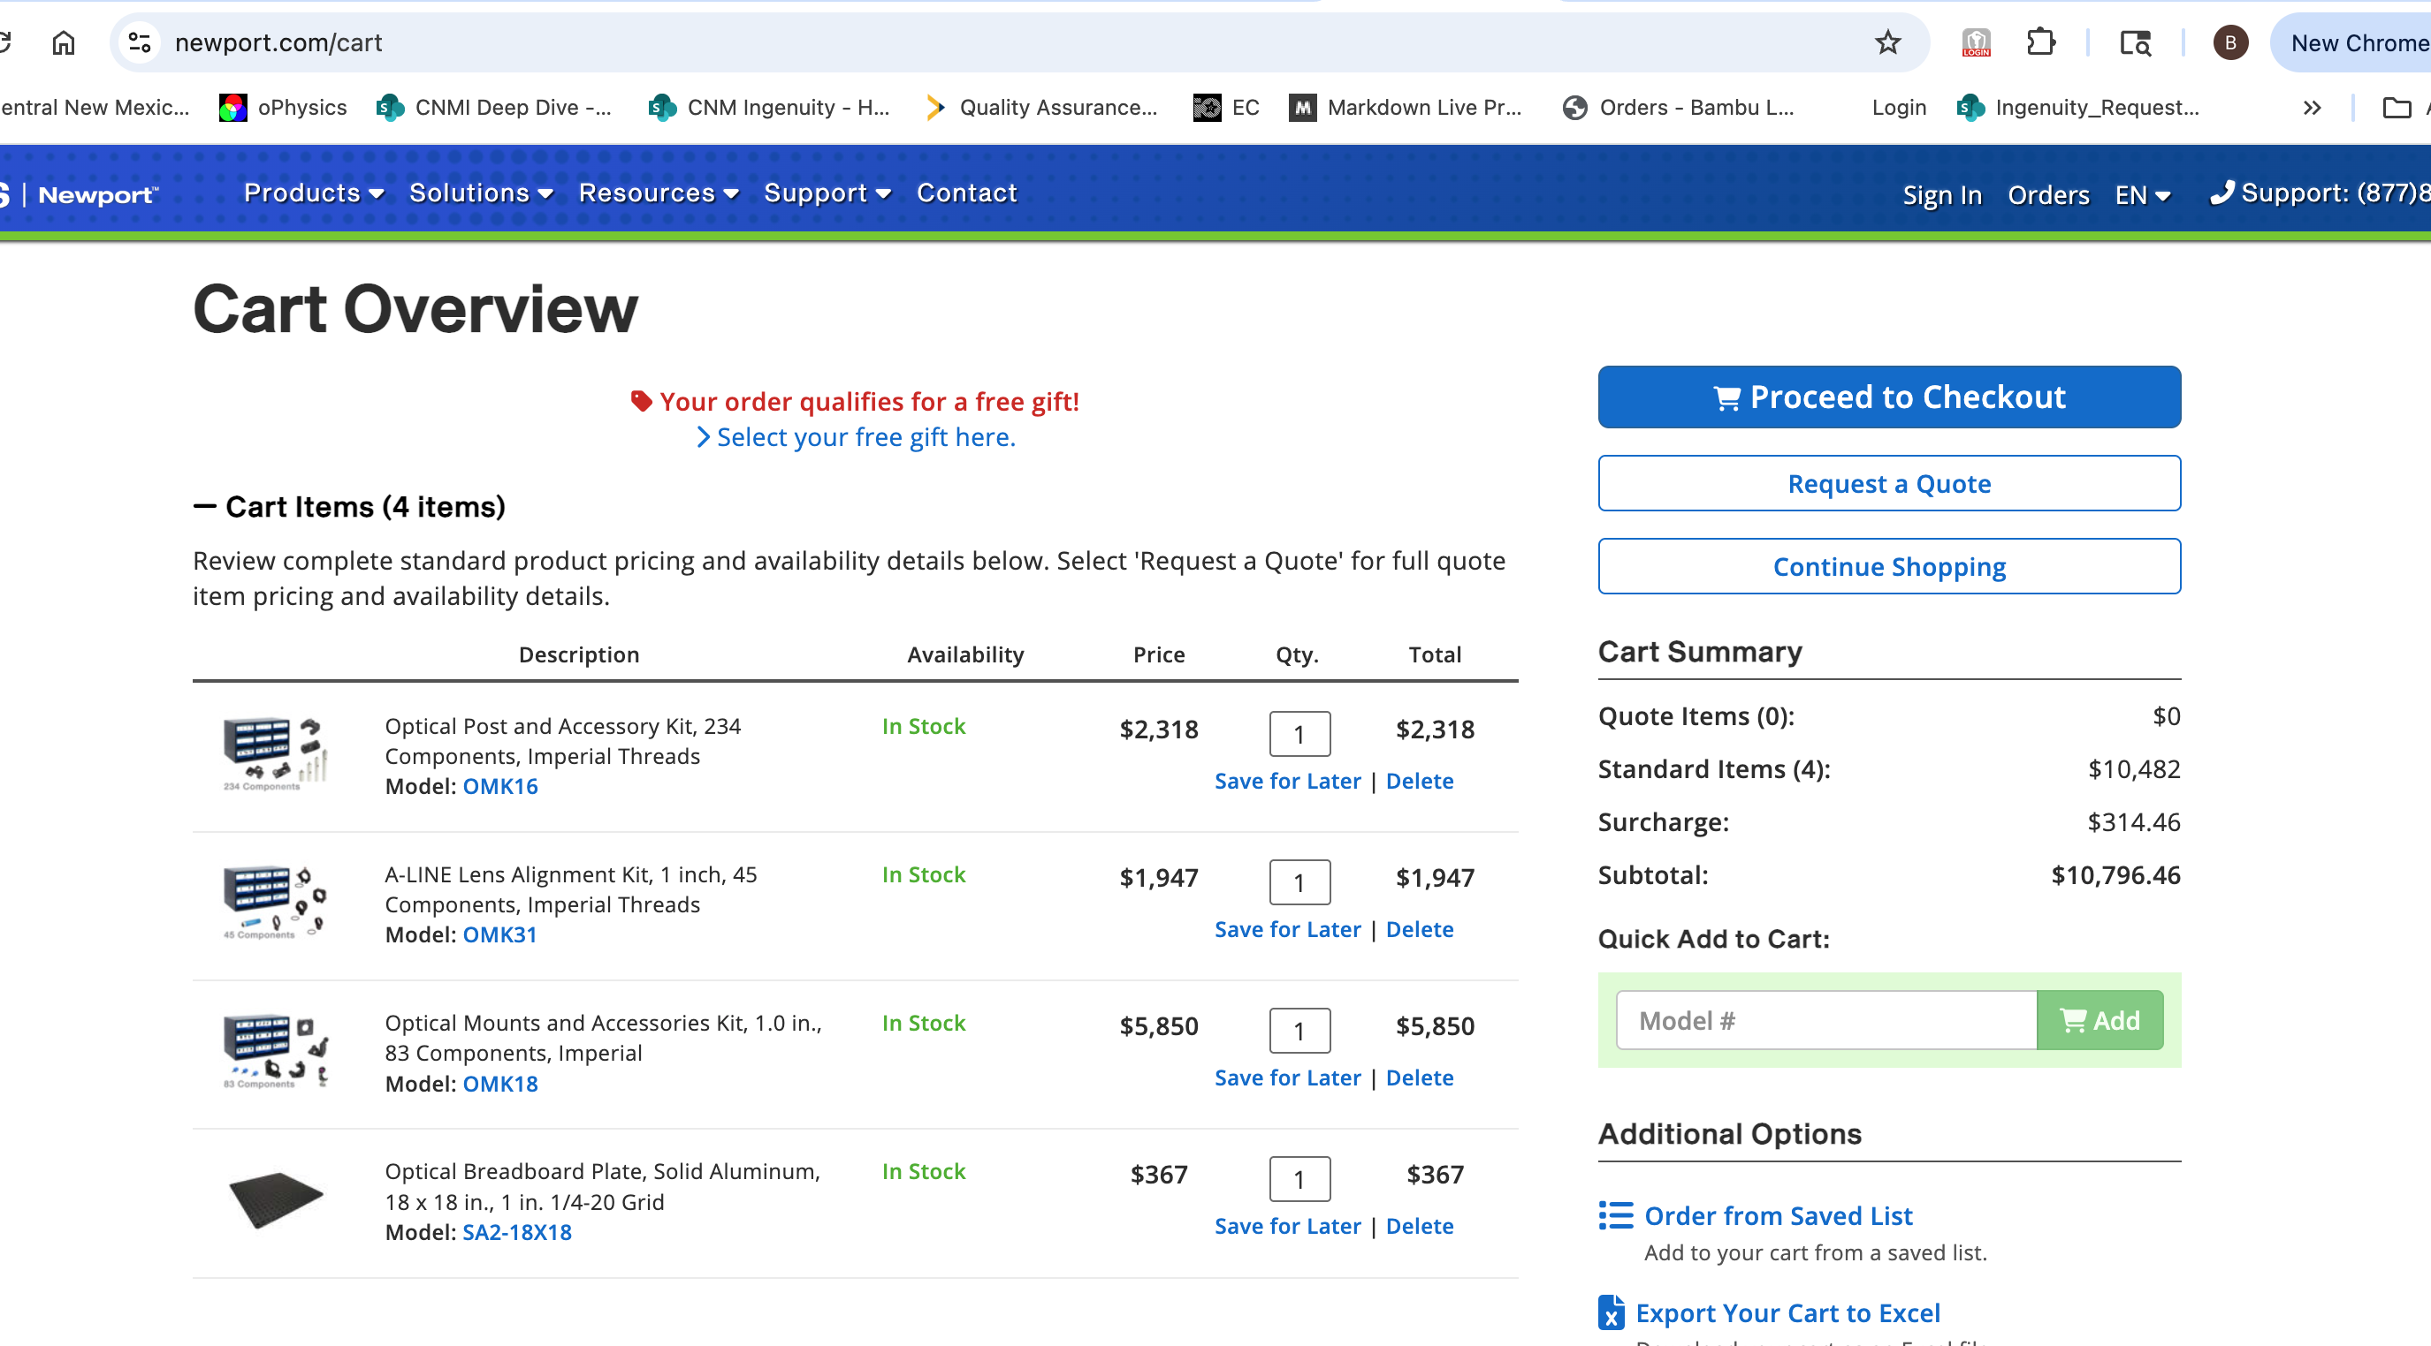

**VENDOR #3: Edmunds**

